**PROGRAMMING FUNDAMENTALS**

***PROJECT REPORT***

**GROUP MEMBERS:**

MEMBER 1

MEMBER 2

MEMBER 3

**ROLE IN THE PROJECT:**

**Member 1**: Primary coder, and research on the game.

**Member 2**: Debugging and fixing errors.

**Member 3**: secondary coder, dry runs.

**MAIN IDEA OF THE PROJECT**

The main idea was to create a Five-card draw (poker version), The goal is: to check the best five-card hand.

In the start, betting takes place and two players are dealt with five random cards., After this, the player with the best hand wins.

**MAIN FEATURES OF THE PROJECT**

* The gamer will be asked how much they want to wager.
* Random generation of cards.
* Similar to actual poker, it will immediately inform the player after the generation of cards if his cards were a pair or a flush (random) (Five-card draw).
* Allocation of bets and the computation of remaining credits.

**SCREENSHOTS**

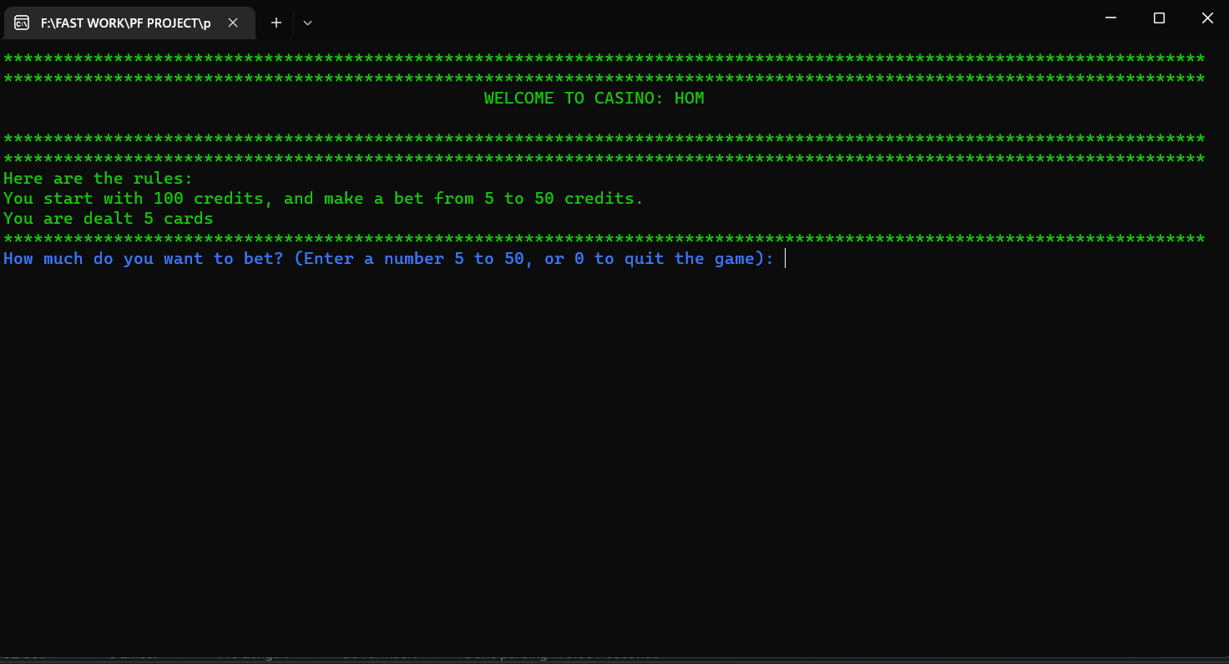

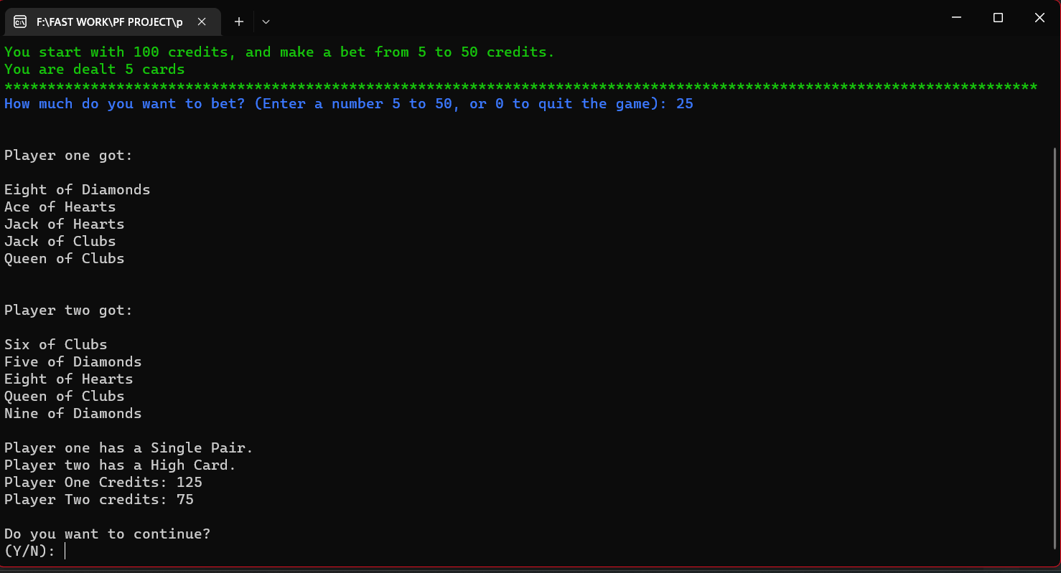

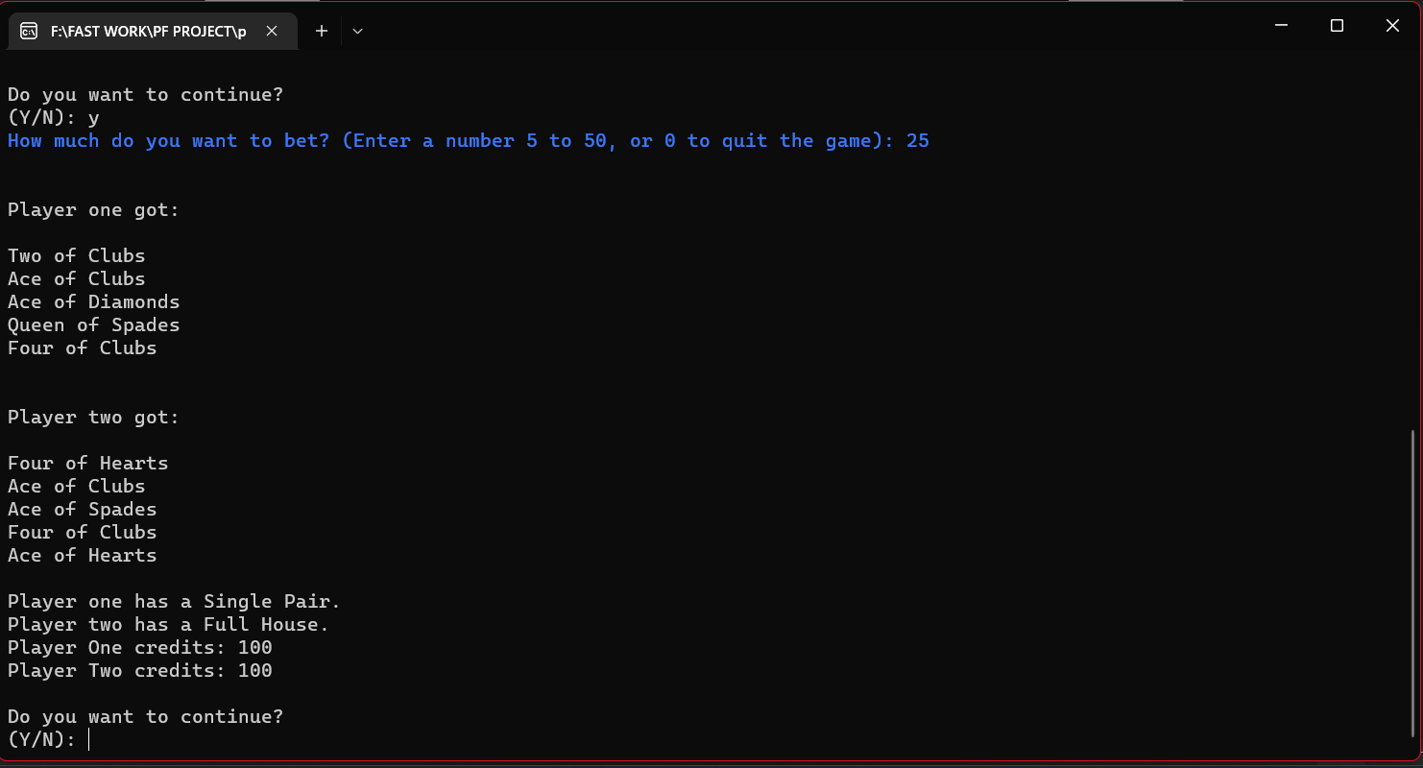

**PROBLEMS:**

* Various problems in generating random cards.
* Getting bet from the user and calculating was small but delicate problem.
* Then many problems in comparing the cards to decide the best hand.
* Giving rank to the best hand.